UC01 Submit Application for Lease
Use Case Name |  | Submit Application for Lease
Use Case Number |  | UC01
mSCOA ID |  | N/A
Use Descriptions: |  | The process for an Applicant to submit a Lease Application
Primary Actor |  | Applicant  Client Services Officer
Secondary Actor(s) |  | Property Lease Management System
Pre-condition(s) |  | Must be successfully logged into the system
Trigger |  | Need to apply for unit to let with EHC
Success End Condition |  | Lease Application successfully submitted
Failed End Condition |  | Lease Application not submitted
Screen References |  | 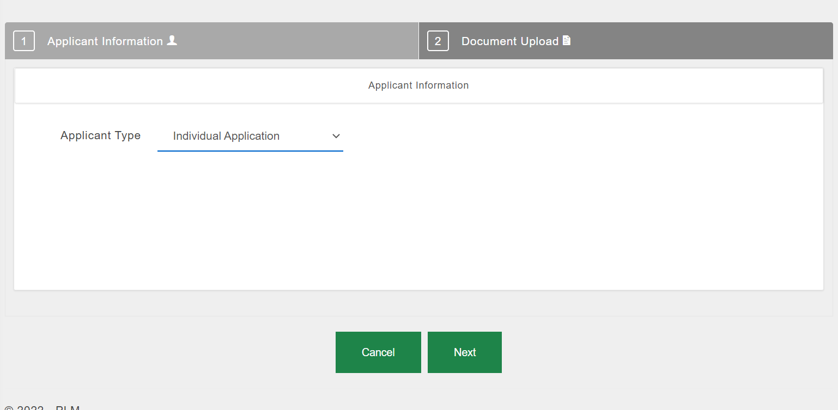  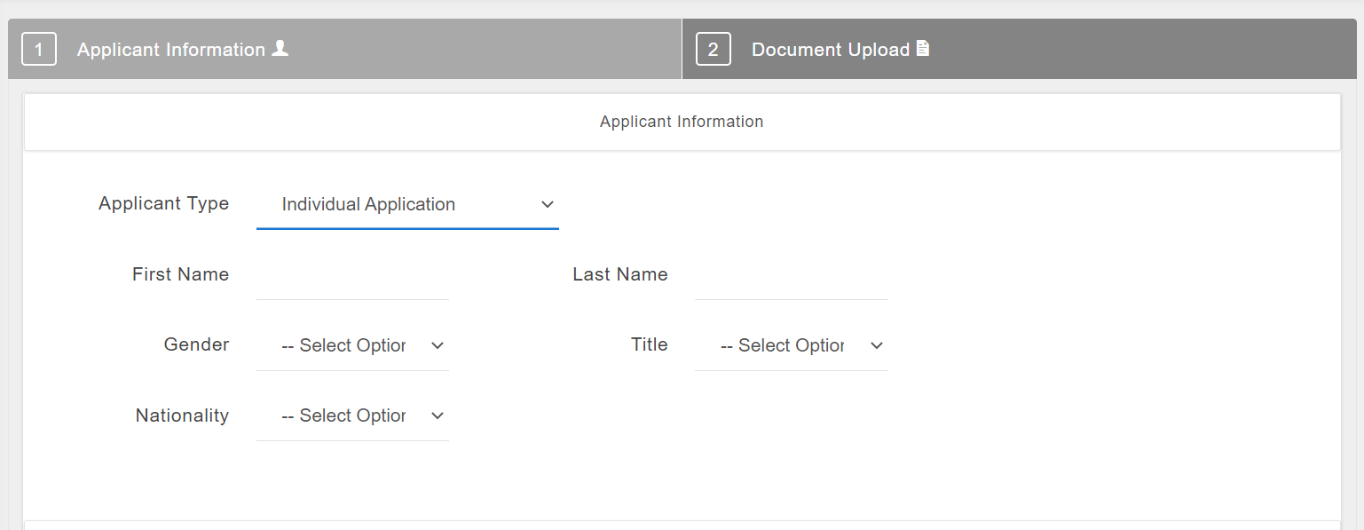  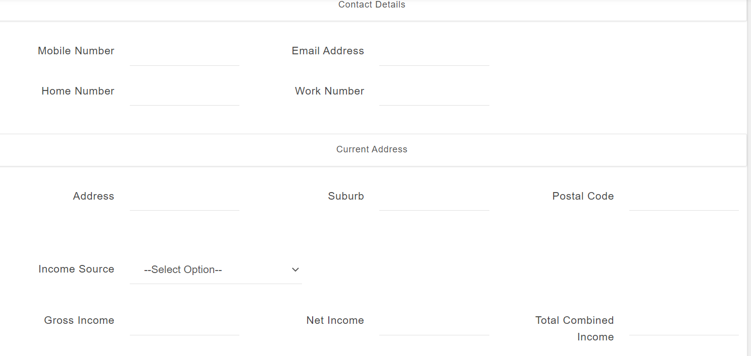  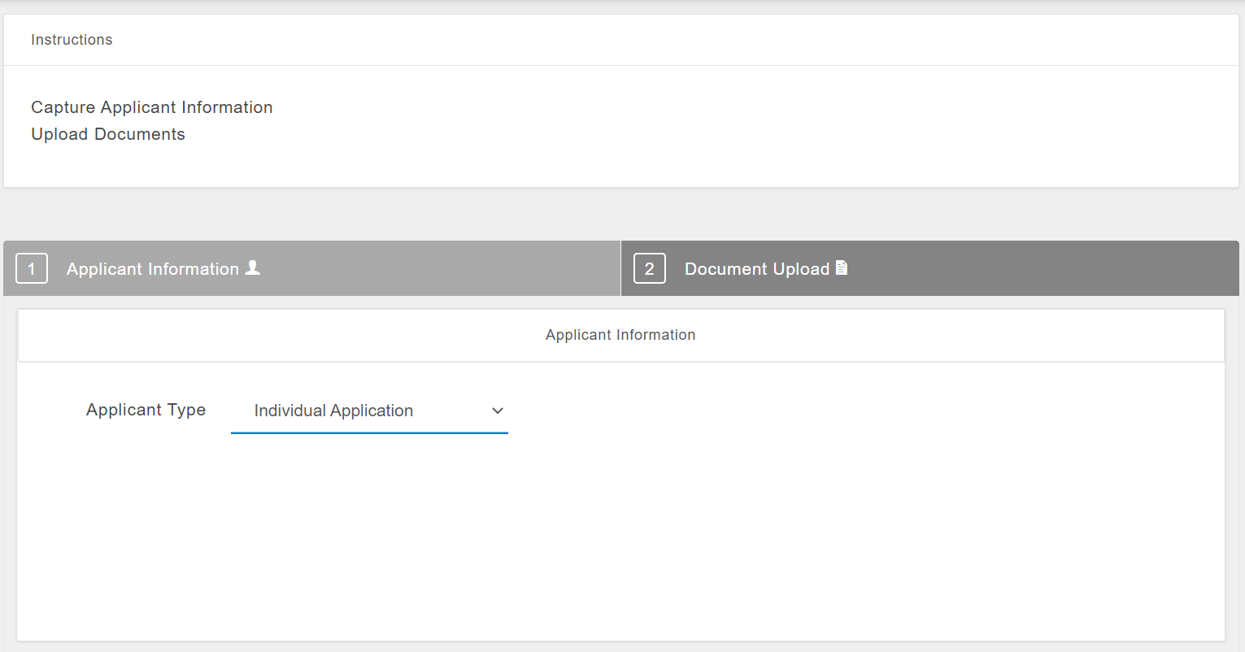  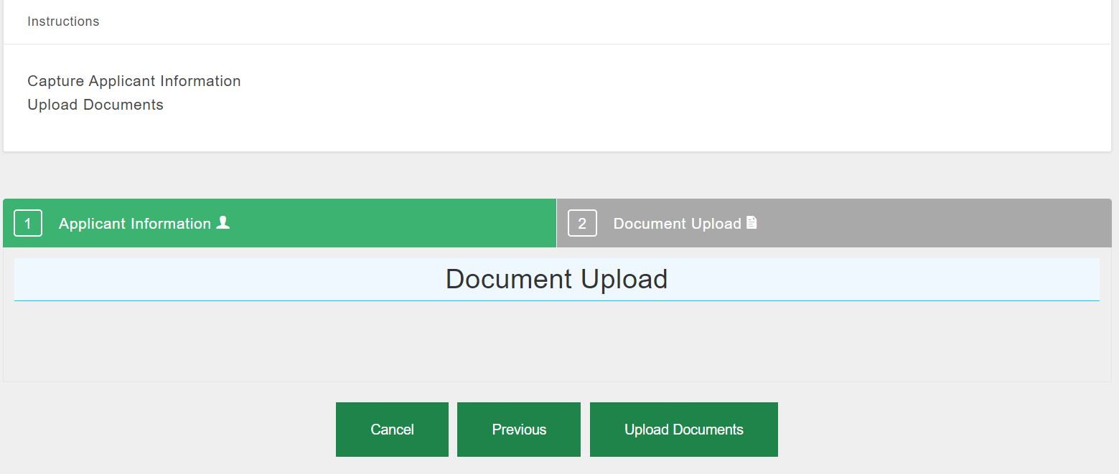
Integration |  | IR14 | ArcGIS
Business Requirements |  | Requirement ID | Requirement Description
 |  | FR5.1 | Functionality for prospective applicants to apply online.
 |  | FR5.2 | Functionality for designated officials to capture applications on behalf of Applicants
 |  | FR5.3 | Ability to attach relevant documents required during applications
 |  | FR5.4 | Allow the applicant to choose the preferred leasing space
 |  | FR5.5 | Allow for applicant to indicate the purpose of the leasing space
 |  | FR5.6 | Allocate Application reference number
 |  | FR5.9 | Validate submitted details against the relevant systems and the waiting list.
 |  | FR5.10 | Disregard the application if the mandatory fields are not filled correctly; and/or documentation are not attached.
 |  | FR5.11 | Ability to track lease application status
 |  | FR5.12 | Ability to send notification to applicant
Business Rules |  | Rule ID | Rule Description
 |  | BR01 | Only one application must be submitted for leasing. ID Numbers must be matched against the waiting list, disregard application if the Applicant ID Number is still active on the waiting list
 |  | BR02 | The unique Reference Number that is system generated for the Applicant during the application stages must not be duplicated
Main Success Scenario [The steps of the scenario from trigger to goal delivery, as well as any clean-up]
Ref | Actor Action |  |  | Ref | System Response
Step 1 | Clicks on PLM Applications |  |  | Step 2 | Present dropdown list
Step 3 | Tab on Capture |  |  | Step 4 | Opens Lease Application Screen
Step 5 | Selects Individual from Applicant Type dropdown list |  |  | Step 6 | Opens Individual Application screen details
Step 7 | Capture the details > Accept the Declaration and Click on next Button |  |  | Step 8 | Validates the information entered,  matches the ID captured against the Waiting List, system accepts user action
Step 9 | Click on Upload Documents > Select documents to be uploaded, and Clicks upload |  |  | Step 10 | Documents uploaded successfully
Step 11 | Click Submit |  |  | Step 12 | Application Reference number generated  Notifications presented “Your lease application has been registered and is Awaiting Application Fee Validation. Please use the details provided to make a payment at the bank indicated. Once payment has been effected please upload the proof of payment for the application to be further processed.”
Step 13 | Click “OK” button |  |  | Step 14 | System accepts confirmation
Alternative Flow 1
Step 7 | Doesn’t capture some of the required mandatory fields |  |  | Step 8 | Highlights the fields that needs to be captured and prompt user to enter.
Alternative Flow 2
Step 7 | Captured ID number exists in the waiting list |  |  | Step 8 | Display message that the ID already exists in the waiting list and discard the application.
Alternative Flow 3
Step 9 | Doesn’t upload the documents |  |  | Step 10 | Updates Application status to Awaiting Document Upload

UC02 Upload Proof of Payment for the Application Fee
Use Case Name |  | Upload Application Fee Proof of Payment
Use Case Number |  | UC02
mSCOA ID |  | N/A
Use Descriptions: |  | The process for uploading proof of application fee payment
Primary Actor |  | Applicant  Client Services Officer
Secondary Actor(s) |  | Property Lease Management System
Pre-condition(s) |  | Must be successfully logged into the system  Application reference number generated
Trigger |  | Need to apply for a unit to let with EHC
Success End Condition |  | Proof of application fee payment successfully submitted
Failed End Condition |  | Unable to upload proof of application fee payment
Screen References |  | 
Integration |  | N/A
Business Requirements |  | Requirement ID | Requirement Description
 |  | FR5.7 | The system must have a functionality that enables the applicant to submit proof of R250 application fee with all the required documents when submitting a lease application
Business Rules |  | Rule ID | Rule Description
 |  | BR03 | When a lease application is being submitted, the applicant must pay an administration fee specified by the Board of Directors of EHC for the application to be processed further
Main Success Scenario [The steps of the scenario from trigger to goal delivery, as well as any clean-up]
Ref | Actor Action |  |  | Ref | System Response
Step 1 | Clicks on PLM Applications |  |  | Step 2 | Presents list of applications recorded
Step 3 | Select application of interest |  |  | Step 4 | Accepts user selection
Step 5 | Click on Document Upload |  |  | Step 6 | Displays list of uploaded documents
Step 7 | Select Proof of Payment upload and Click on upload |  |  | Step 8 | Accepts user activity
Step 9 | Click Submit |  |  | Step 10 | Accepts user activity and displays notification: “Your application is awaiting Risk Assessment. You will be notified by email/SMS once your risk assessment outcome has been captured.”

UC03 Validate Application Fee Payment
Use Case Name |  | Validate Application Fee Payment
Use Case Number |  | UC03
Use Descriptions: |  | The process of validating application fee payment
Primary Actor |  | Bookkeeper
Secondary Actor(s) |  | Property Lease Management System
Pre-condition(s) |  | Must be successfully logged into the system.
Trigger |  | Need to validate application fee payment
Success End Condition |  | Payment successfully validated
Failed End Condition |  | Payment not successfully validated
Screen References |  | 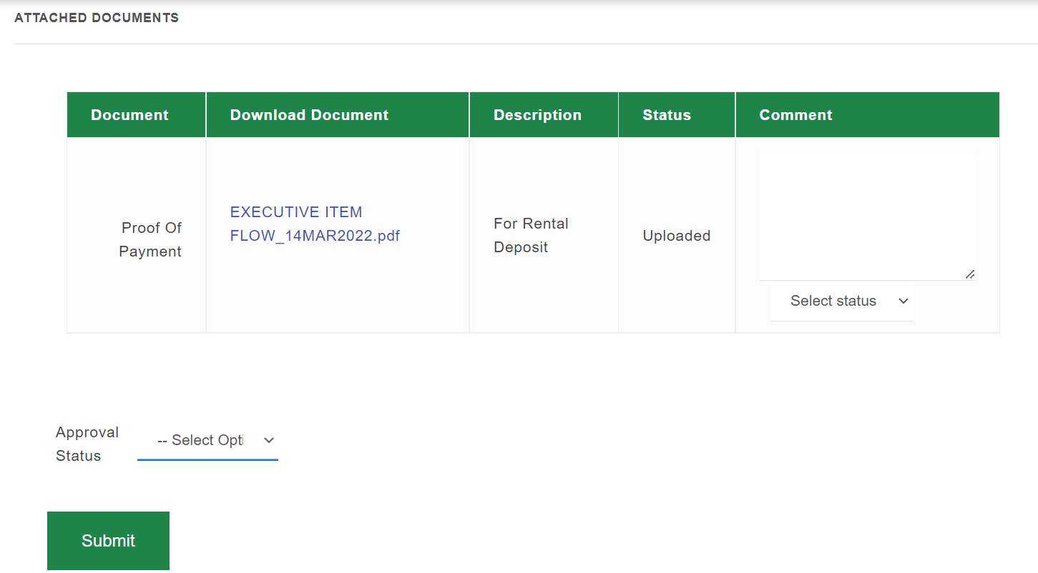
mSCOA ID |  | N/A
Integration |  | N/A
Business Requirements |  | Requirement ID | Requirement Description
 |  | FR5.8 | The system must have a functionality to enable the Bookkeeper to validate payment
Business Rules |  | Rule ID | Rule Description
 |  | BR03 | When a lease application is being submitted, the applicant must pay an administration fee specified by the Board of Directors of EHC for the application to be processed further
Main Success Scenario [The steps of the scenario from trigger to goal delivery, as well as any clean-up]
Ref | Actor Action |  |  | Ref | System Response
Step 1 | Selects Financials from the main menu |  |  | Step 2 | Lists all available options on the dropdown list
Step 3 | Selects Application Fee Payments |  |  | Step 4 | Displays “Awaiting Payment Validation” Screen
Step 5 | Selects the Application whose payment is to be validated by clicking on “View” |  |  | Step 6 | Opens Attached Documents Screen
Step 7 | Check the document and select Approve to approve that the document is aligning and Click Submit |  |  | Step 8 | System presents a notification “Are you sure you want to submit the following document approval?”
Step 9 | Click on “Yes I am sure” |  |  | Step 10 | System closes notification  Application status = Awaiting Risk Assessment Outcome
Alternative Flow 1 (Alternative at Step 7)
Step 7 | Check the document and select Rejected > Capture Reason and Click Submit |  |  | Step 8 | Confirmation page is displayed
Step 9 | Click on “Yes, I am sure” |  |  | Step 10 | Notification is sent to the Applicant with rejection based on reasons submitted on the captured Reason  Application status = Awaiting Application Fee Payment Validation

UC04 Capture Risk Assessment Outcome and Approval
Use Case Name |  | Capture Risk Assessment Outcome and Approval
Use Case Number |  | UC04
Use Descriptions: |  | The process for Backoffice official to capture Risk Assessment Outcome on the application.
Primary Actor |  | Client Services Officer; Revenue Manager; CEO
Secondary Actor(s) |  | Property Lease Management System
Pre-condition(s) |  | Must be successfully logged into the system
Trigger |  | Lease Application Awaiting Risk Assessment Outcome
Success End Condition |  | Risk Assessment Outcome successfully captured
Failed End Condition |  | Risk Assessment Outcome not successfully captured
Screen References |  | 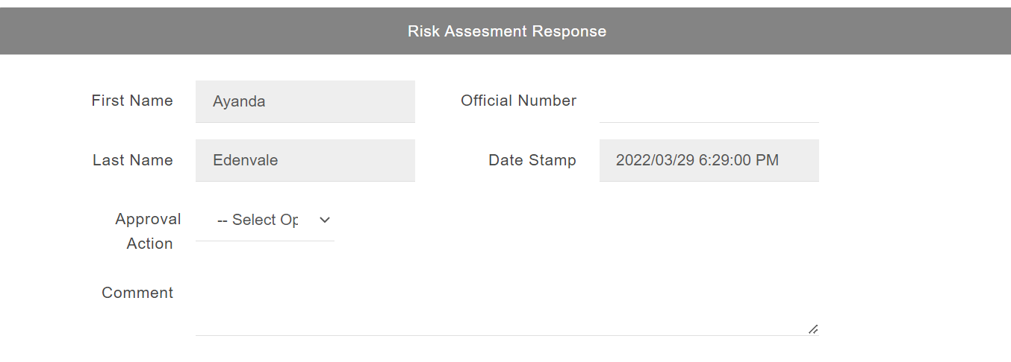  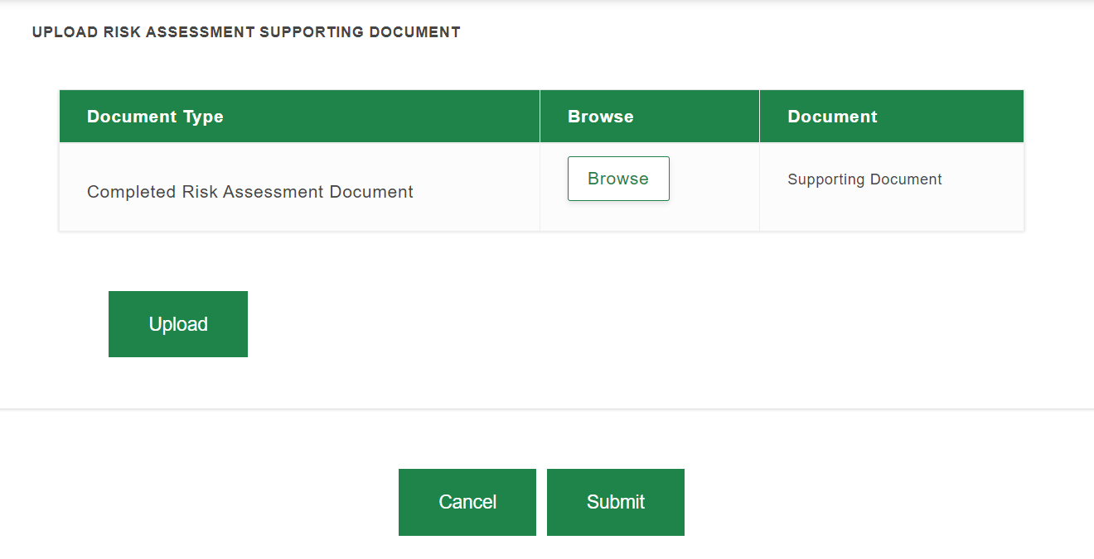
mSCOA ID |  | N/A
Integration |  | IR09 |  | Credit Bureaus Tenant Network Profile: to verify credit profile details of the applicants.
 |  | IR10 |  | Home Affairs: to verify ID number and marital status details for the applicants.
 |  | IR11 |  | Deeds: to verify property ownership details for the applicants.
 |  | IR12 |  | South African Social Security Agency: to verify social grant details for the applicants.
Business Requirements |  | Requirement ID | Requirement Description
 |  | FR5.4 | Applicants have option to choose 2 complexes and unit sizes (1bed, 2beds, 3beds etc.).
 |  | FR5.9 | Check ID number against Home Affairs and Marital Status where applicable. Applications with invalid details must be discarded. Applicants on Waiting List with Active Status must be discarded
 |  | FR5.11 | By entering the Application Reference Number, Applicant or Delegated Official should be able to track the status of the Lease Application.
 |  | FR6.1 | The system must have a functionality to enable the Client Services Officer to conduct and capture ITC checks and other Risk Assessment checks, make recommendations.
 |  | FR6.2 | Capture risk assessment outcome
 |  | FR6.3 | Once recommendations are made by Client Services Officer, the system must enable the Revenue Manager to support the recommendation and there after route the application to the CEO for approval or rejection
 |  | FR6.4 | Once the application is appraised, the system must have a functionality to move it to the CEO for approval or rejection with reasons (mandatory) and notification sent to Applicant as well as the Client Services Officer (for Approved application, Status = Add to Waiting List)
 |  | FR6.5 | The system must have a functionality to automatically add applicant to Waiting list if there are no units available in the original complex of choice
Business Rules |  | Rule ID | Rule Description
 |  | BR04 | Applicants who own any property according to deeds records are not eligible to apply for rental housing.  ID Number search must be done against the deeds records and the system must disregard the application.
 |  | BR05 | Reason field is mandatory for any capture reason step
 |  | BR08 | For each complex, 30% of the units must be reserved for R6 000- and lower-income potential tenants
Main Success Scenario: Client Services Officer flow
Ref | Actor Action |  |  |  | Ref | System Response
Step 1 | Clicks on PLM Applications > Selects Assessment from the main menu |  |  |  | Step 2 | Lists available options on the dropdown list
Step 3 | Selects Risk Assessment option |  |  |  | Step 4 | Opens the Risk Assessment Response Screen with All Customer applications that are in awaiting Risk Assessment status
Step 5 | Search or select an application from the list and tab Assess |  |  |  | Step 6 | Application details page presented and system accepts user action  Notification “Document(s) Uploaded” presented
Step 7 | Click on ITC/TPN check link: https://mrisoftware.tpn.co.za |  |  |  | Step 8 | Directs to the applicable page (user can then perform the required checks & download the required document (s))
Step 9 | Capture Risk Assessment Outcome by selecting Recommended from the dropdown list |  |  |  | Step 10 | System accepts user selection
Step 11 | Capture Reason (Mandatory) |  |  |  | Step 12 | Accepts user input
Step 13 | Capture the Matching Unit Details (based on assessment outcome) |  |  |  | Step 14 | Accepts user input
Step 15 | Select Upload Documents > Click on Upload button |  |  |  | Step 16 | Accepts user input
Step 17 | Click on the Submit button |  |  |  | Step 18 | Message presented “Are you sure you want to submit the following recommendation?”
Step 19 | Click on “Yes, I am sure” from the Notification |  |  |  | Step 20 | Success message displayed  Application status = Awaiting Approval  Notification sent to the Revenue Manager
Alternative Flow 1 (Alternative at Step 9)
Step 7 | User selects Not Recommended on Risk Assessment Outcome |  |  |  | Step 8 | System accepts user selection
Step 9 | Capture Reason (Mandatory) |  |  |  | Step 10 | Accepts user input
Step 11 | Click on the Submit button |  |  |  | Step 12 | Notify Applicant of the Risk Assessment outcome that their application was unsuccessful based on reasons submitted on the captured Reason
Main Success Scenario: Revenue Manager Flow
Step 1 | Clicks on PLM Applications > Selects Inbox Applications from the menu |  |  |  | Step 2 | List of applications display
Step 3 | Select required application with status Awaiting Approval |  |  |  | Step 4 | Application details from the risk assessment outcome display
Step 5 | Enter Official number, Click on Authorize > Select Supported > Capture Reason (Mandatory) |  |  |  | Step 6 | Official number, authorization action, comments accepted
Step 7 | Click on Submit |  |  |  | Step 8 | Message presented “Are you sure you want to submit the following recommendation?”
Step 9 | Click on “Yes, I am Sure” button |  |  |  | Step 10 | Success message displayed  Application status = Awaiting CEO Approval  Notification sent to the CEO
Alternative Flow 1 (Alternative at Step 5)
Step 5 | Enter Official number, Click on Authorize > Select Not Supported > Capture Reason (Mandatory) |  |  |  | Step 6 | Official number, authorization action, comments accepted
Step 7 | Click on Submit |  |  |  | Step 8 | Message presented “Are you sure you want to submit the following response?”
Step 9 | Click on “Yes, I am Sure” button |  |  |  | Step 10 | Notify Applicant and Client Services Officer of the Risk Assessment outcome that their application was unsuccessful based on reasons submitted on the captured Reason
Main Success Scenario: CEO Flow
Step 1 | Clicks on PLM Applications > Selects Inbox Applications from the menu |  |  |  | Step 2 | List of applications display
Step 3 | Select required application with status Awaiting Approval |  |  |  | Step 4 | Application details from the risk assessment outcome display
Step 5 | Enter Official number, Click on Authorize > Approve > Capture Reason (Mandatory) |  |  |  | Step 6 | Official number, authorization action, comments accepted  Approval Date defaults on current system date
Step 7 | Clicks Submit |  |  |  | Step 8 | Message presented “Are you sure you want to submit the following approval?”
Step 9 | Click on “Yes, I am Sure” button |  |  |  | Step 10 | System accepts user input  Success message displayed  Notification sent to Applicant that their lease application has been approved and that they have been matched to unit based on affordability assessment  System automatically puts applicant on the Waiting List based on Typology Match and CEO Approval Date  Application status = Added to Waiting List/ Pending Allocation
Alternate Flow 1 (Alternative at Step 5)
Step 5 | Enter Official number, Click on Authorize > Select Rejected > Capture Reason (Mandatory) |  |  |  | Step 6 | Official number, authorization action, comments accepted
Step 7 | Click on Submit |  |  |  | Step 8 | Message presented “Are you sure you want to submit the following response?”
Step 9 | Click on “Yes, I am Sure” button |  |  |  | Step 10 | Notify Applicant, Client Services Officer and Revenue Manager of the Risk Assessment outcome that their application was unsuccessful based on reasons submitted on the captured Reason

UC05 Accept Unit Offer
Use Case Name | Accept Unit offer by Applicant
Use Case Number | UC05
Use Descriptions: | The process for the Applicant to accept the unit offer they have been matched to.
Primary Actor | Applicant
Secondary Actor(s) | Property Lease Management System
Pre-condition(s) | Notification of unit match received.  Must be successfully logged into the system.
Trigger | Offer matched to requested/available unit based on their preference when applying.
Success End Condition | Applicant accepts the unit they are matched to.
Failed End Condition | Applicant does not accept the unit they are matched to.
Screen References | 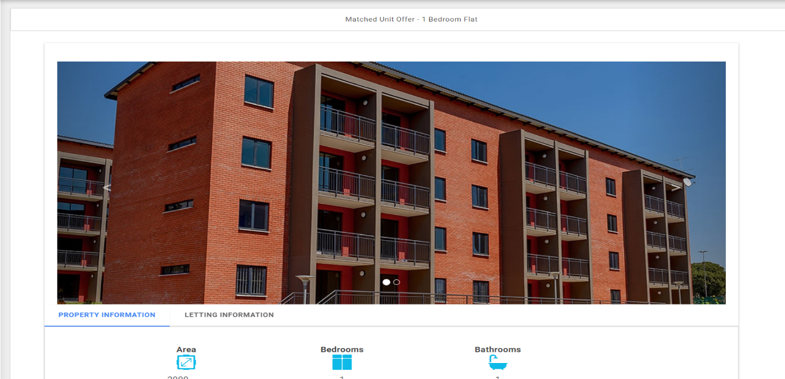  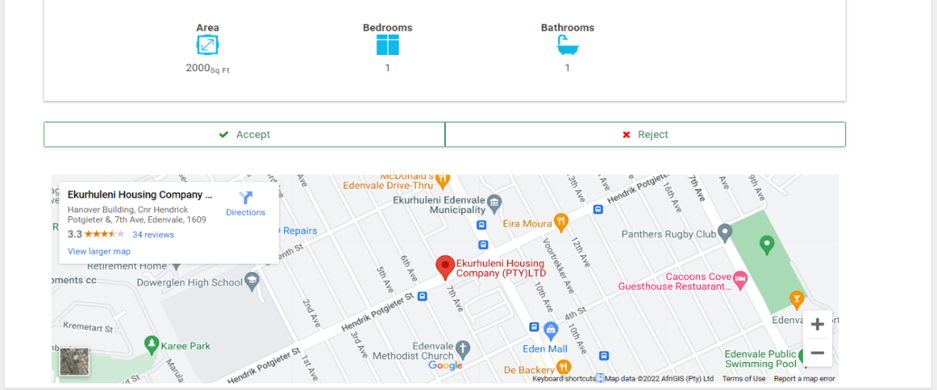
mSCOA ID | N/A
Integration | IR14 | ArcGIS
Business Requirements | Requirement ID | Requirement Description
 | FR5.12 | Ability to send notification to applicant
 | FR6.6 | Priority must be based on the number in the queue and selected preferred options (CEO Approval Date & Typology applied for). Communicate to prospective tenant with alternative suggestion if unit is available in another complex (which was not of initial preference). If offer is refused, application remains on Waiting List. If offer is accepted, process should initiate Deposit Payment and Unit Inspection processes (Application status = Pending Allocation)
 | FR6.7 | Automatically abort an application after two refused offers
Business Rules | Rule ID | Rule Description
 | BR06 | The services such as water and electricity must be grouped according to the unit size and refusal service must remain standard.
 | BR08 | For each complex, 30% of the units must be reserved for R6 000- and lower-income potential tenants
 | BR09 | Matched units that have not been accepted after 30 days must be withdrawn and matched to the next matching Applicant from the list.
 | BR11 | Remove applicant from waiting list after two (2) rejections of available unit offers.
Main Success Scenario [The steps of the scenario from trigger to goal delivery, as well as any clean-up]
Ref | Actor Action |  | Ref | System Response
Step 1 | After receiving the matching notification, log into the system and click PLM Applications |  | Step 2 | Lists all available options on the dropdown
Step 3 | Selects inbox |  | Step 4 | Shows the application with status available unit matched
Step 5 | Clicks View button |  | Step 6 | Shows the details of the unit and deposit amount
Step 7 | Clicks Accept |  | Step 8 | Success message displayed  Notification sent “Thank you for accepting the offer to lease a unit with EHC. Your application is Awaiting Deposit Payment. Please use the details provided to make a payment at the bank indicated. Once payment has been effected please upload the proof of payment for further processing.”  (Application status = Awaiting Deposit Payment)
Alternative Flow 1
Step 7 | Selects Reject |  | Step 8 | Check the number of times the Applicant has rejected
Step 9 | Rejects first time |  | Step 10 | Retains their space on the waiting list
Alternative Flow 2
Step 9 | Selects Reject a match second time |  | Step 10 | Remove Applicant from the Waiting list.  Notification sent to applicant that they have been removed from the waiting list and will need to restart application if still interested in leasing a unit with EHC

UC06 Upload Proof of Deposit Payment
Use Case Name | Upload Proof of Deposit Payment
Use Case Number | UC06
Use Descriptions: | The process of capturing deposit payment by the Applicant
Primary Actor | Applicant  Client Services Officer
Secondary Actor(s) | Property Lease Management System
Pre-condition(s) | Must be successfully logged into the system.  Application reference number generated.  Application status must be awaiting deposit payment
Trigger | Applicant has accepted unit offer.
Success End Condition | Proof of deposit payment captured successfully
Failed End Condition | Proof of deposit not successfully captured
Screen References | 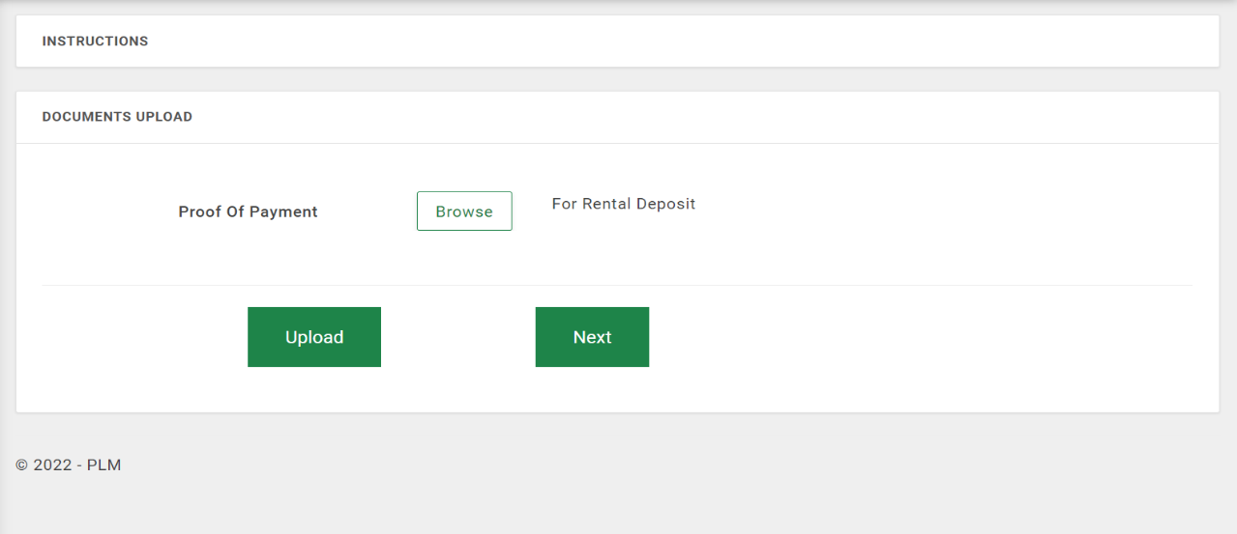
mSCOA ID | N/A
Business Requirements | Requirement ID | Requirement Description
 | FR5.7 | Functionality to attach proof of payment for applicable application fee and deposits
Business Rules | Rule ID | Rule Description
 | BR06 | The services such as water and electricity must be grouped according to the unit size and refusal service must remain standard.
 | BR28 | To process a tenant deposit refund: (1) Tenant must have vacated the unit;(2) Account must not be in arrears and (3) Exit inspection must have been done.
 | BR29 | Any deposits made by Tenant are refundable on termination of supply of services provided that all outstanding amounts have been settled. A deposit will be forfeited if not claimed within 12 months
Main Success Scenario [The steps of the scenario from trigger to goal delivery, as well as any clean-up]
Ref | Actor Action |  | Ref | System Response
Step 1 | Click on PLM Applications |  | Step 2 | Displays options under PLM Applications
Step 3 | Selects Application “Inbox” from dropdown |  | Step 4 | Display all applications with status Awaiting Deposit Payment
Step 5 | Selects Application with Status Awaiting Deposit Payment you were working on, by clicking on “Upload proof of payment” |  | Step 6 | Documents page presented
Step 7 | Attach proof of payment, by clicking on browse button |  | Step 8 | Proof of payment is attached
Step 9 | Click on the upload button |  | Step 10 | Document upload success message is displayed
Step 11 | Click OK button |  | Step 12 | Confirmation message disappears
Step 13 | Click Next button |  | Step 14 | Success message displayed  Application status = Awaiting Deposit Validation
Alternative Flow 1
Step 9 | Clicks upload without attaching proof of payment |  | Step 10 | Displays error message that “please select files to be uploaded”.

UC07 Confirm by Applicant when on Waiting List
Use Case Name | Confirm when on waiting list by Applicant
Use Case Number | UC07
Use Descriptions: | The process for the Applicant to confirm they are still interested in leasing while still on waiting list.
Primary Actor | Applicant; Client Services Officer
Secondary Actor(s) | Property Lease Management System
Pre-condition(s) | Must be successfully logged into the system.  Must be on the waiting list
Trigger | Flagged applications for interest confirmation
Success End Condition | Applicant confirms that they are still interested and retain their spot in the waiting list.
Failed End Condition | Applicant does not confirm that they are still interested in leasing and are removed from the waiting list.
Screen References | 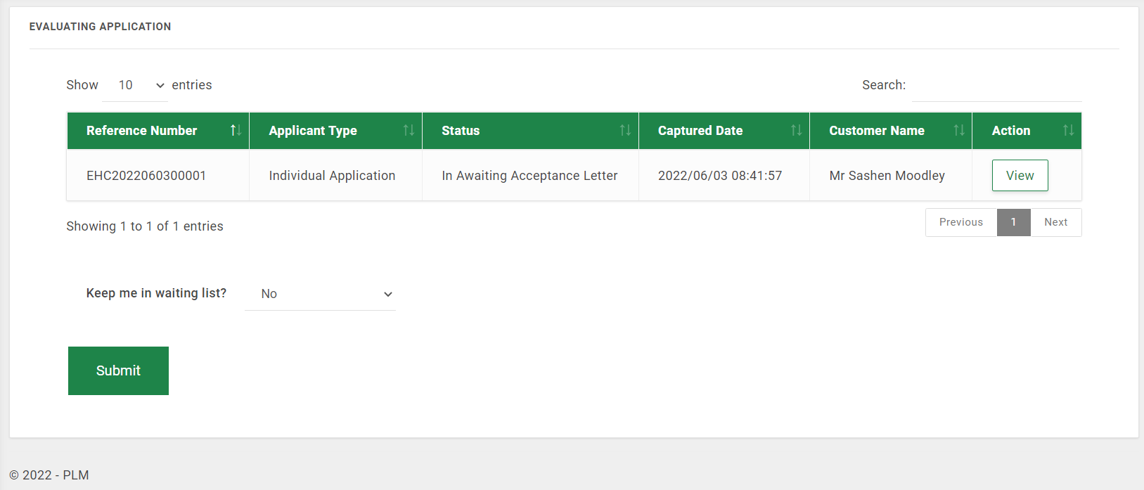
mSCOA ID | N/A
Integration | N/A
Business Requirements | Requirement ID |  | Requirement Description
 | FR6.8 |  | Send notification to applicants when the period on the waiting list is about to lapse and give them an option to indicate whether they are still interested or not.
 | FR6.9 |  | Functionality for Applicant to confirm they are still interested in leasing the unit.
Business Rules | Rule ID |  | Rule Description
 | BR07 |  | Flag applications that need to be confirmed by the 5th month after application was approved.  Remove applicant from waiting list after 6 months if there was no indication that they are still interested after notification has been sent out.
Main Success Scenario [The steps of the scenario from trigger to goal delivery, as well as any clean-up]
Ref |  | Actor Action |  | Ref | System Response
Step 1 |  | Selects PLM Applications |  | Step 2 | Lists all available options under PLM Applications
Step 3 |  | Selects Inbox |  | Step 4 | Shows the lease application to be confirmed
Step 5 |  | Click Unit Still Required? button |  | Step 6 | Opens confirm Screen with Still interested in leasing a unit field with YES or No Option
Step 7 |  | Selects YES |  | Step 8 | Display confirmation received message; and retain the Applicant’s slot on the waiting list
Alternative Flow 1
Step 7 |  | Selects Reject |  | Step 8 | Displays a message prompting user to confirm
Step 9 |  | Confirms that they are no longer interested |  | Step 10 | Displays a message that the Application has been cancelled and applicant has been removed from the waiting list.

UC08 Validate Deposit Payment
Use Case Name |  | Validate Deposit Payment
Use Case Number |  | UC08
Use Descriptions: |  | The process of validating deposit payment
Primary Actor |  | Bookkeeper
Secondary Actor(s) |  | Property Lease Management System
Pre-condition(s) |  | Must be successfully logged into the system.
Trigger |  | Needs to validate proof of deposit payment
Success End Condition |  | Deposit payment successfully validated
Failed End Condition |  | Deposit payment not successfully validated
Screen References |  | 
mSCOA ID |  | N/A
Integration |  | N/A
Business Requirements |  | Requirement ID | Requirement Description
 |  | FR5.8 | The system must have a functionality to enable the Bookkeeper to validate payment
Business Rules |  | Rule ID | Rule Description
 |  | BR28 | To process a tenant deposit refund: (1) Tenant must have vacated the unit;(2) Account must not be in arrears and (3) Exit inspection must have been done.
 |  | BR29 | Any deposits made by Tenant are refundable on termination of supply of services provided that all outstanding amounts have been settled. A deposit will be forfeited if not claimed within 12 months
Main Success Scenario [The steps of the scenario from trigger to goal delivery, as well as any clean-up]
Ref | Actor Action |  |  | Ref | System Response
Step 1 | Selects Financials from the main menu |  |  | Step 2 | Lists all available options on the dropdown list
Step 3 | Selects Deposit Payments |  |  | Step 4 | Displays “Awaiting Deposit Payment Validation” Screen
Step 5 | Selects the Application whose deposit is to be validated by clicking on “View” |  |  | Step 6 | Opens Attached Documents Screen
Step 7 | Check the document > Select Approve > Click Submit |  |  | Step 8 | System presents a notification “Are you sure you want to submit the following document approval?”
Step 9 | Tab on “Yes I am sure” |  |  | Step 10 | Success message displayed  Notification sent to Applicant and Client Services Officer  Application status = Pending Pre-Occupation Inspection
Alternative Flow 1 (Alternative at Step 7)
Step 7 | Check the document and select Rejected > Capture Reason and Click Submit |  |  | Step 8 | Confirmation page is displayed
Step 9 | Click on “Yes, I am sure” |  |  | Step 10 | Notification is sent to the Applicant with rejection based on reasons submitted on the captured Reason  Application status = Awaiting Deposit Payment Validation

